ShopHub

___________________________________________

Website Documentation

Customer Guide

___________________________________________

Student Name: Nischal Aryal

Student ID: 77261069

Module Name: Production Project

. HOME page

For first-time users of the ShopHub web interface, new users must first register in order to purchase any item on the site. The icon in the first navigation bar will direct the user with options to login or register as a new user.

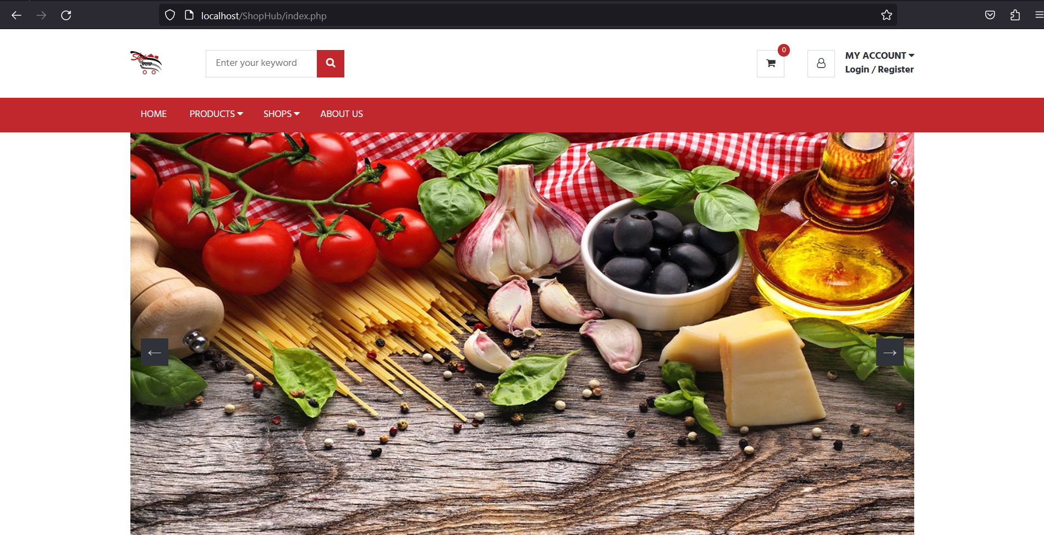

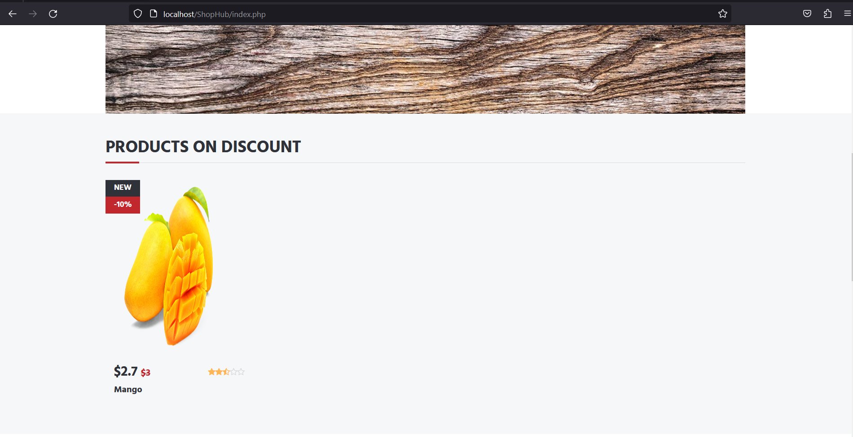

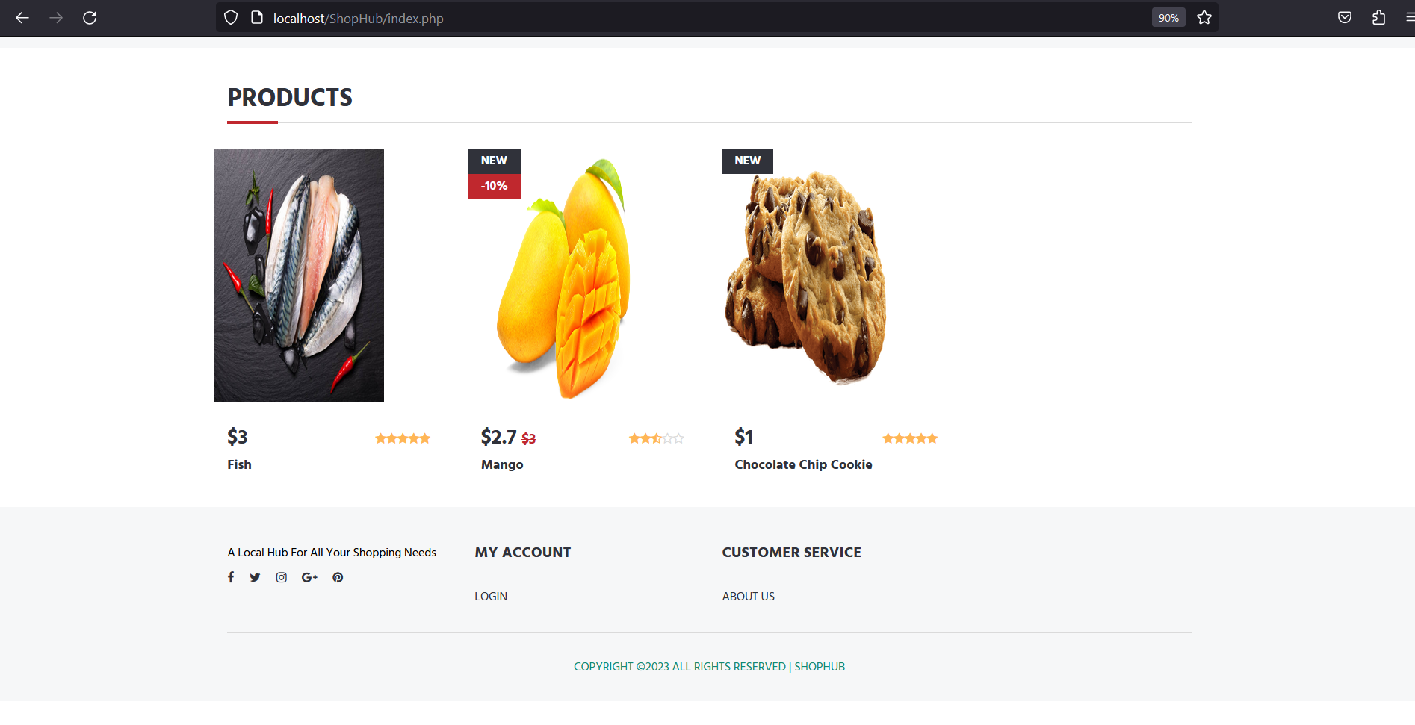

II. REGISTER PAGE (FOR CUSTOMERS)

After being redirected to the Register page for Customer, users will be showcased with the registration form where users must fill out all of the information that we have requested.

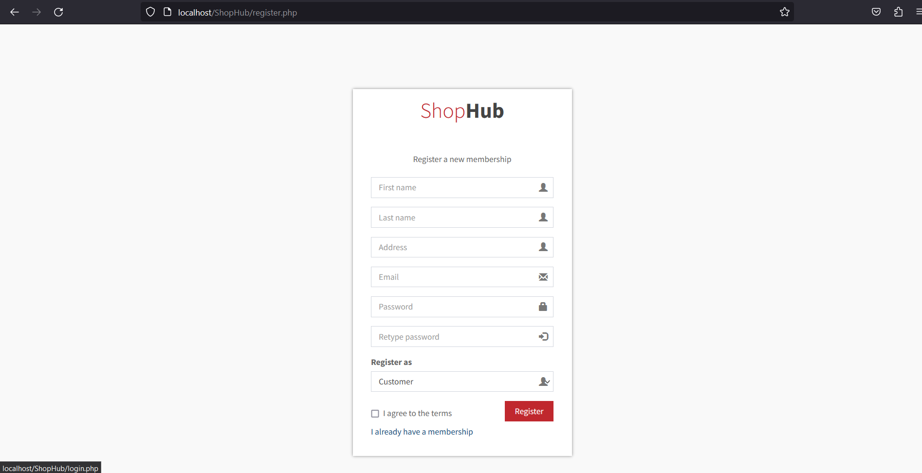

III. LOGIN (FOR EXISISTING USERS)

Registered Customers can now login to the system with their email as username and password they had setup initially.

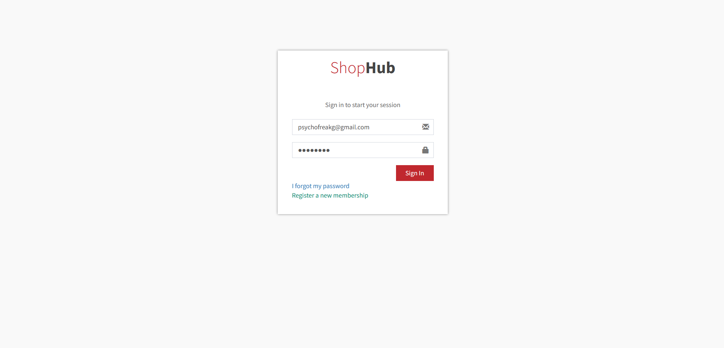

Iv. PRODUCT SEARCH and Sort

Users can browse through products with different filter options on the navigation bar, either by product category or by vendors/shops accordingly.

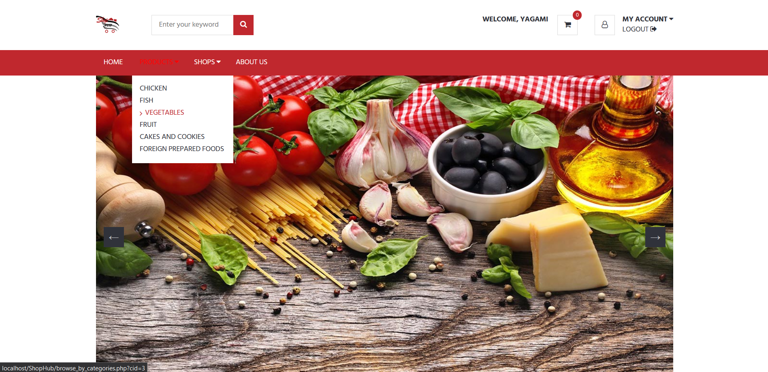

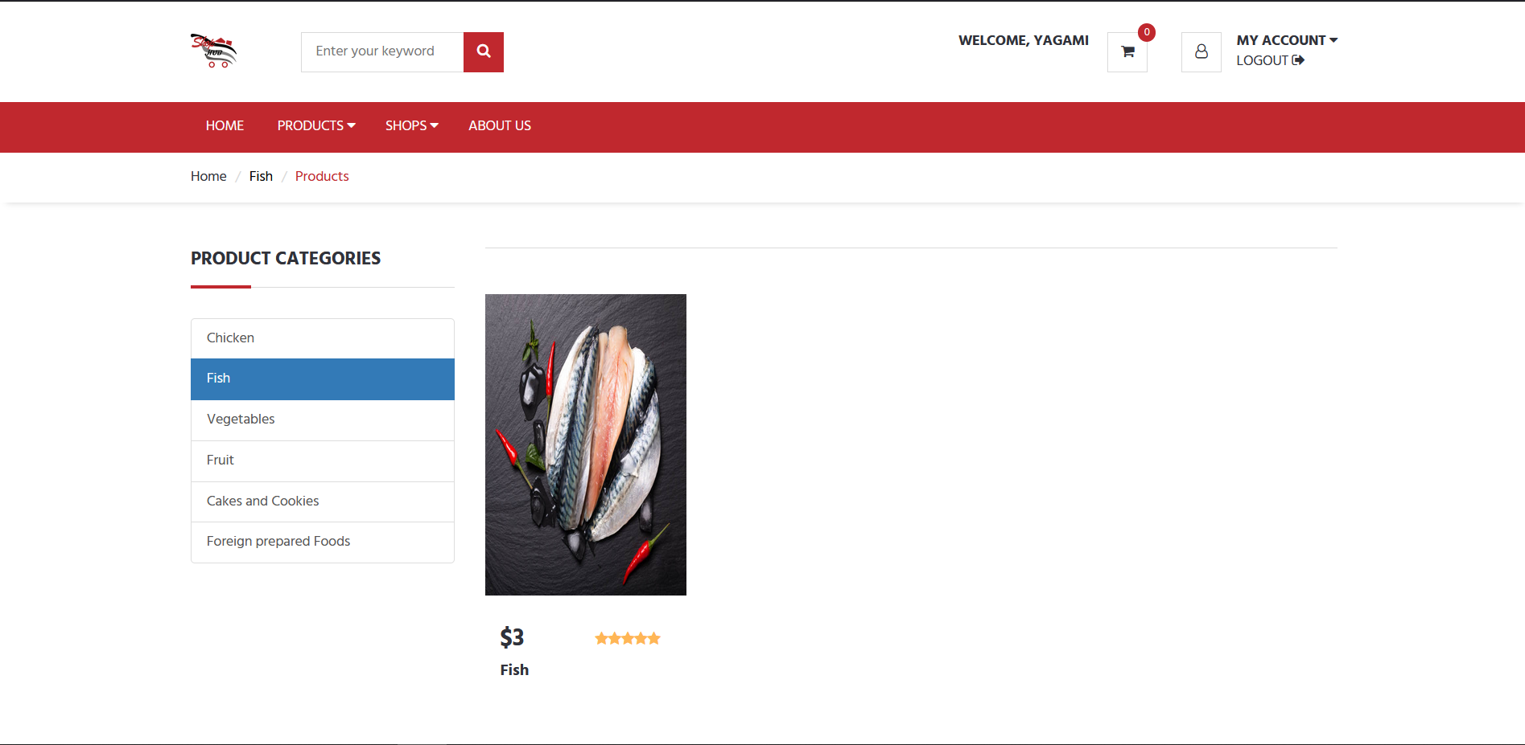

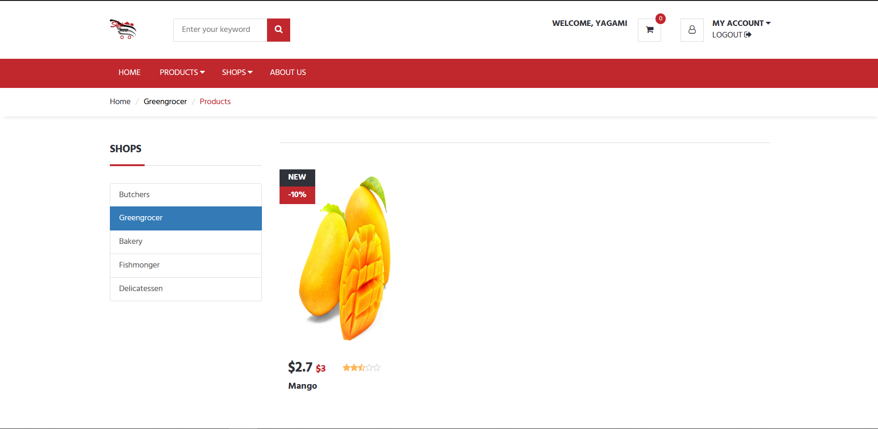

v. PRODUCT DETAIL

The assessment of Product Detail page which highlights all the information about the corresponding product for the user to make a wise choice.

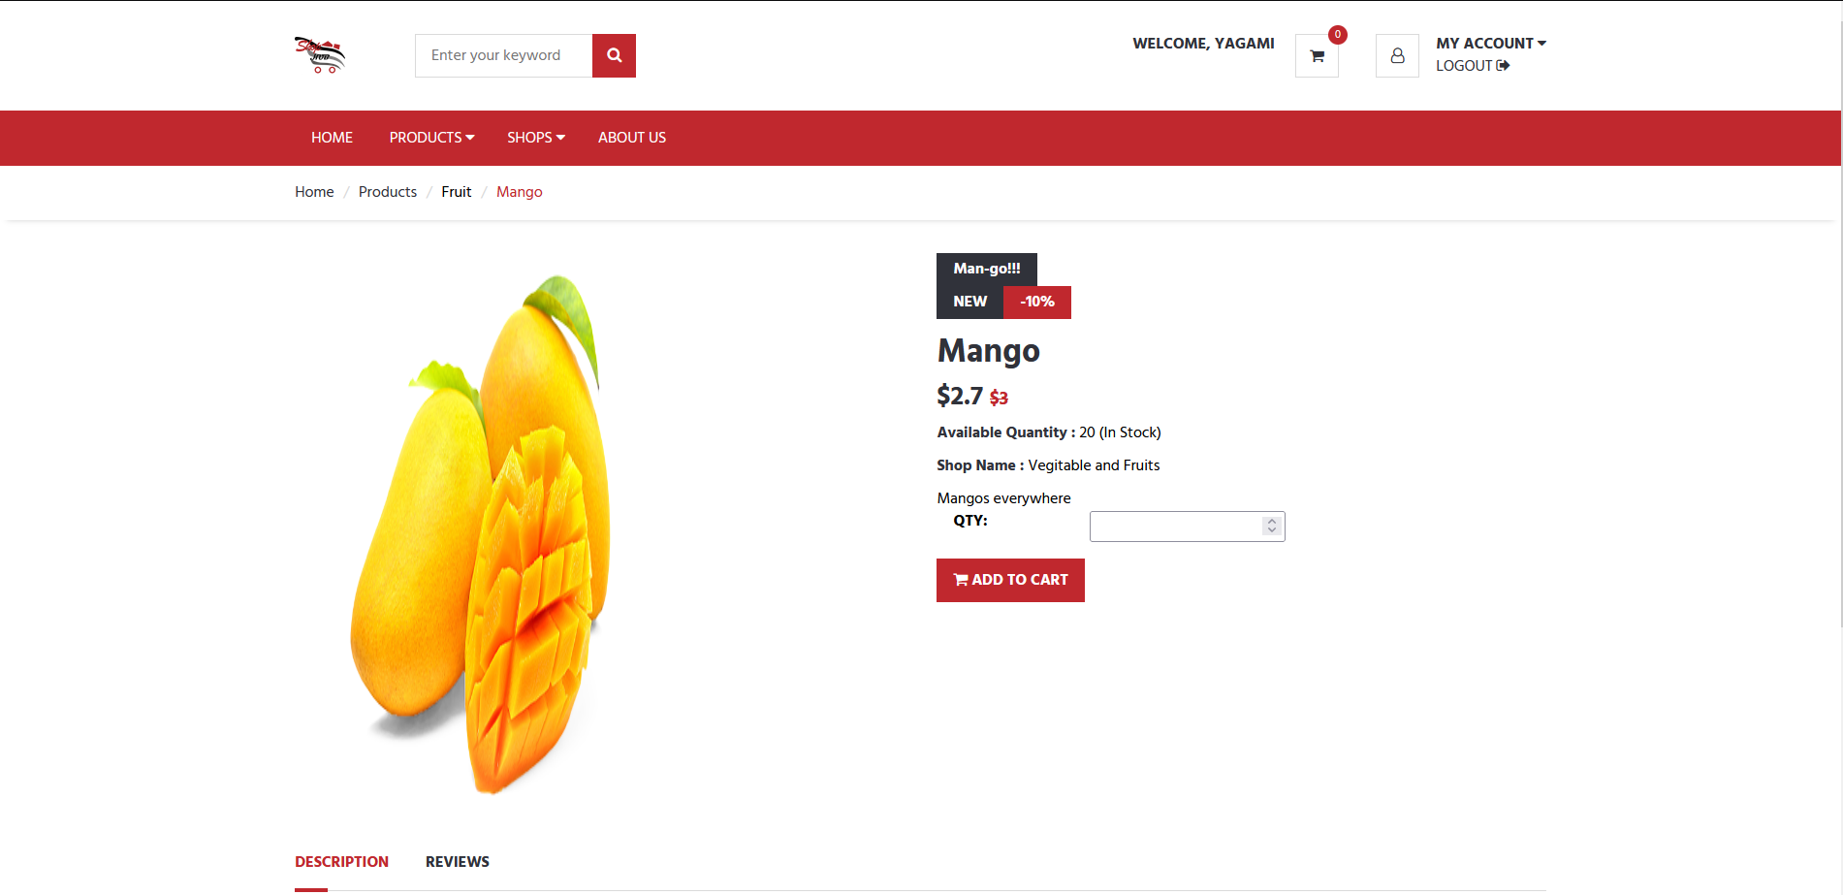

vI. ADD TO CART

After the customers make a choice, they can add the product to the cart. The cart page will present all the products they have added along with the quantity and price accordingly.

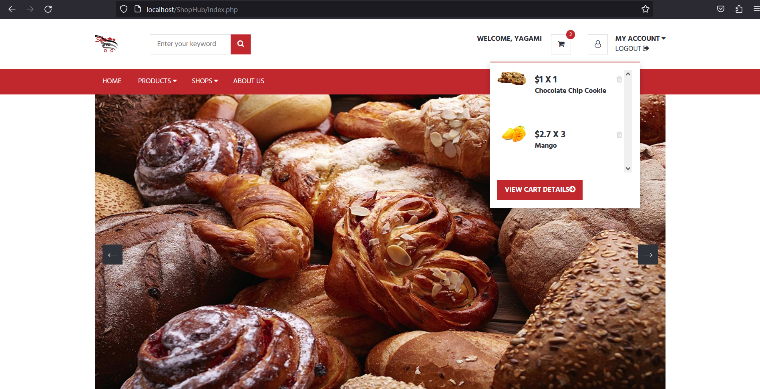

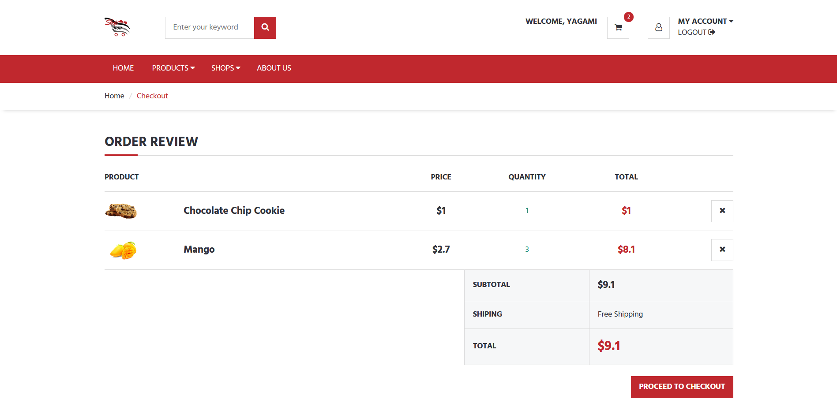

vII. REVIEW and ratings

Customers can also give reviews and ratings to the products. If customers had already given a review of a specific product, then their review gets updated if they decide to write a review for that same product.

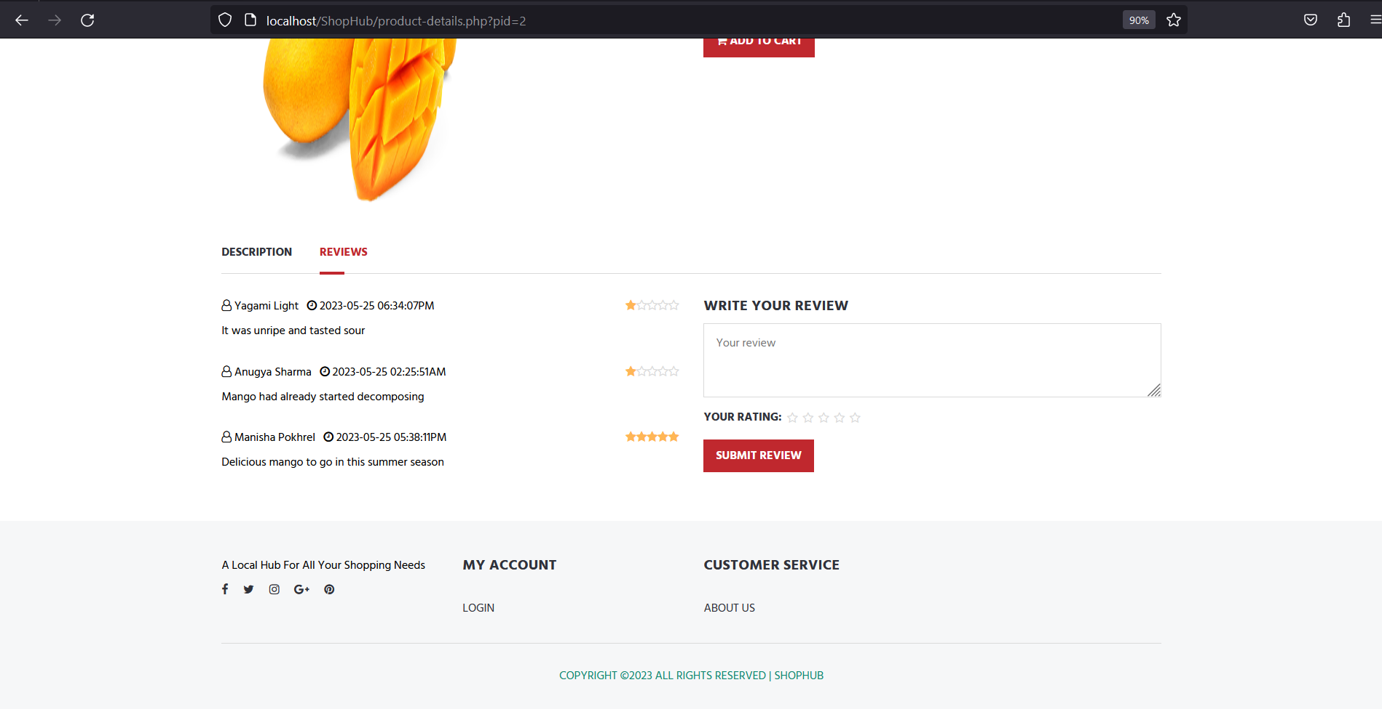

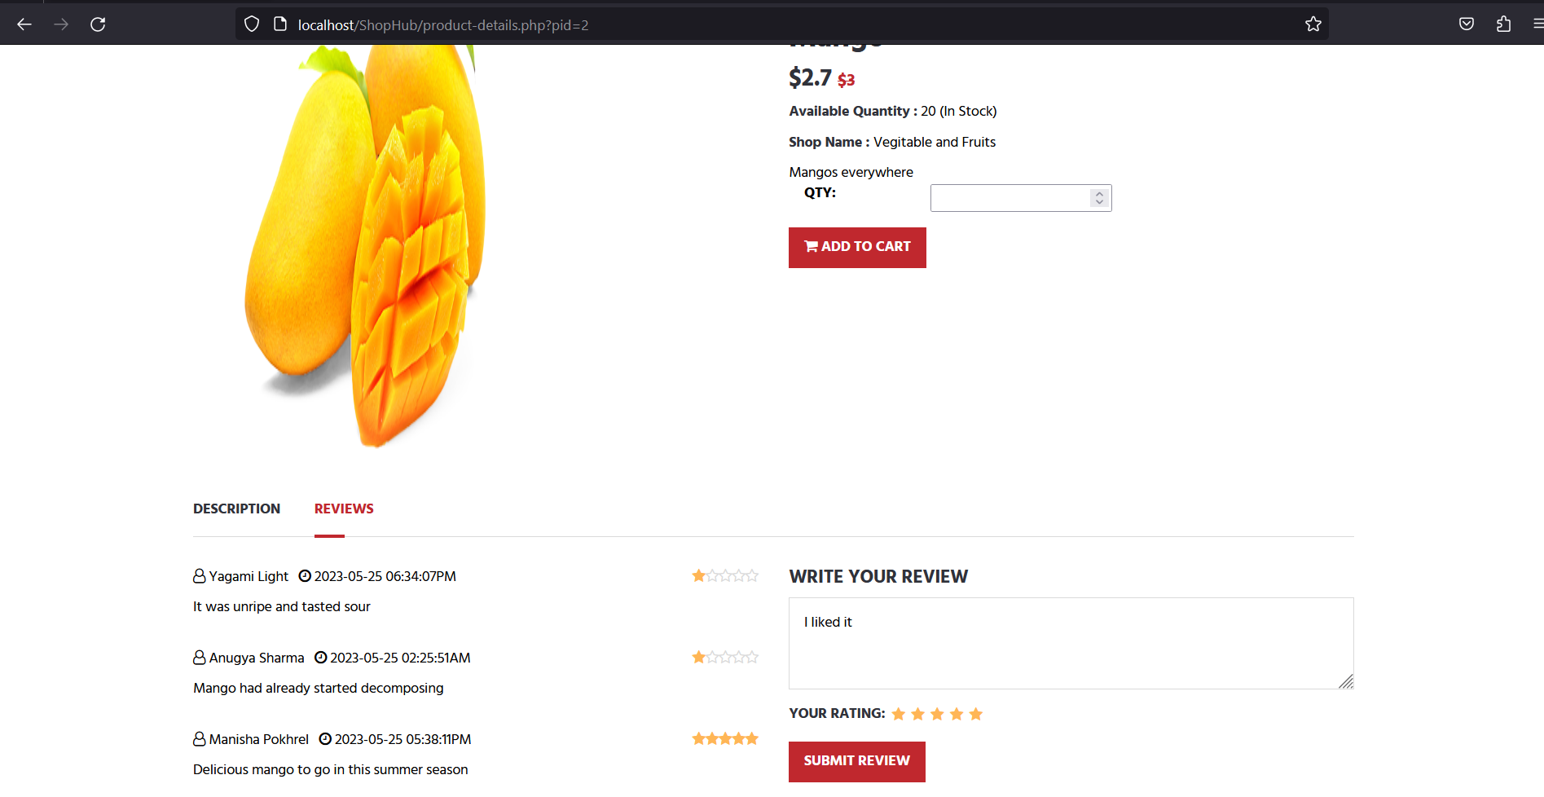

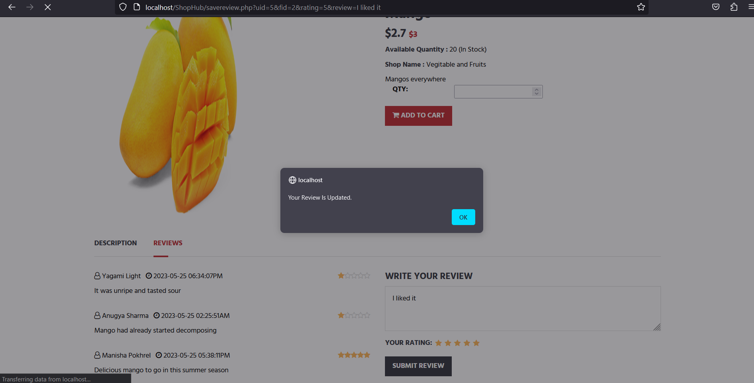

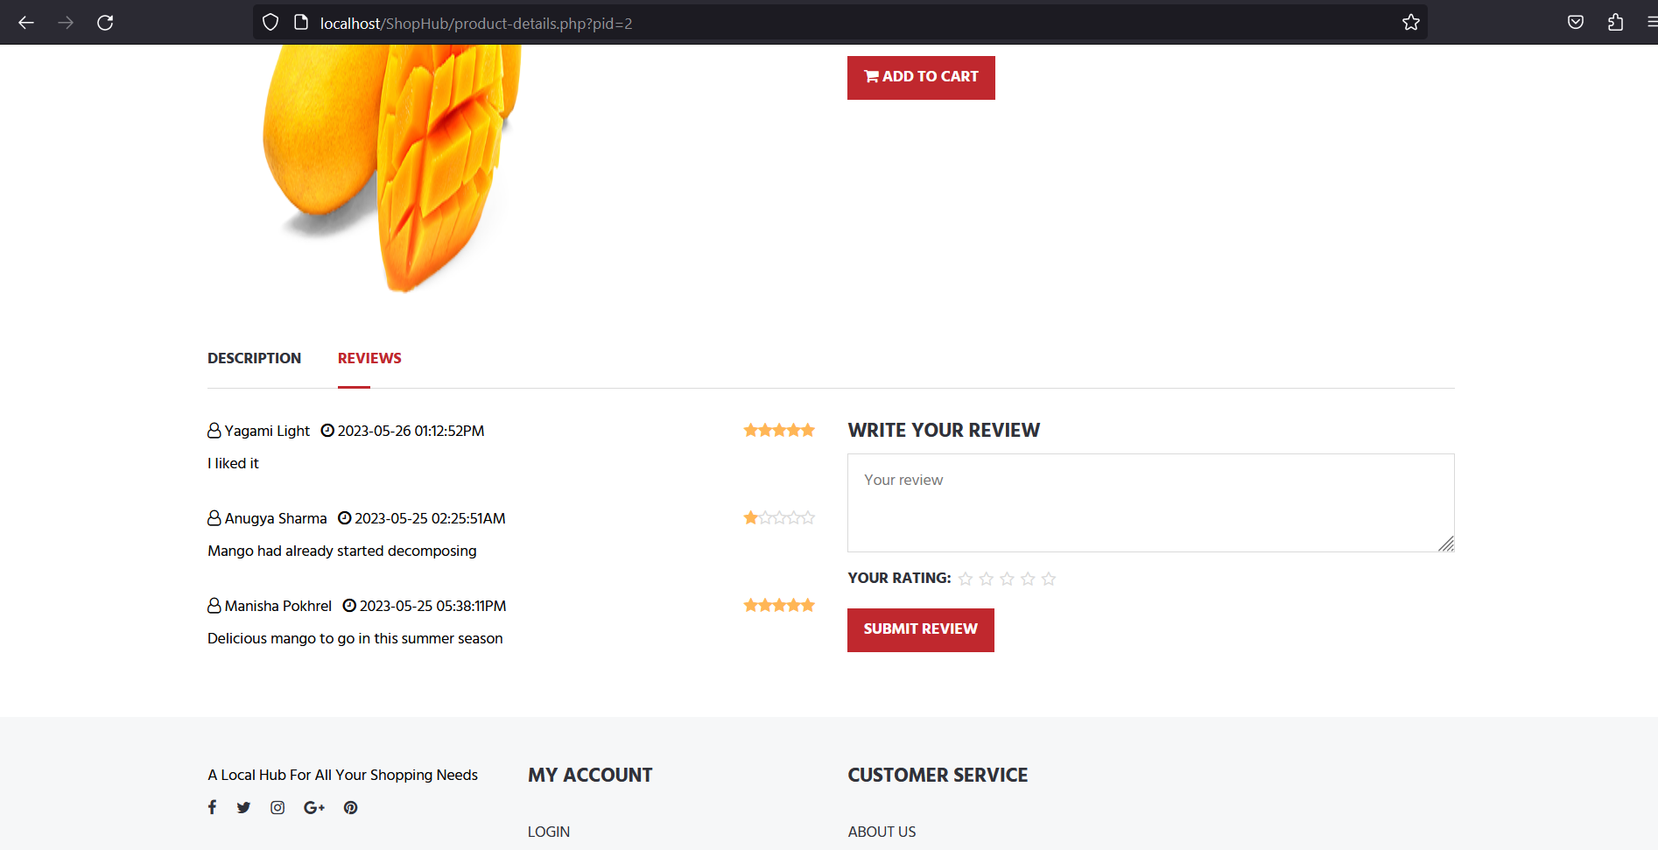

viii. PROCEED TO CHECKOUT

A summary of order will be showcased with the total price.

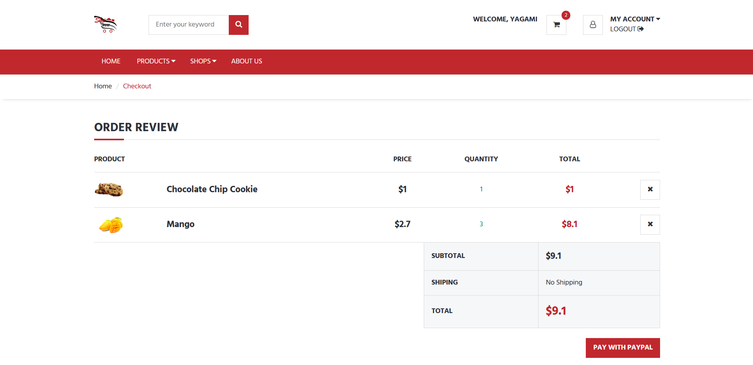

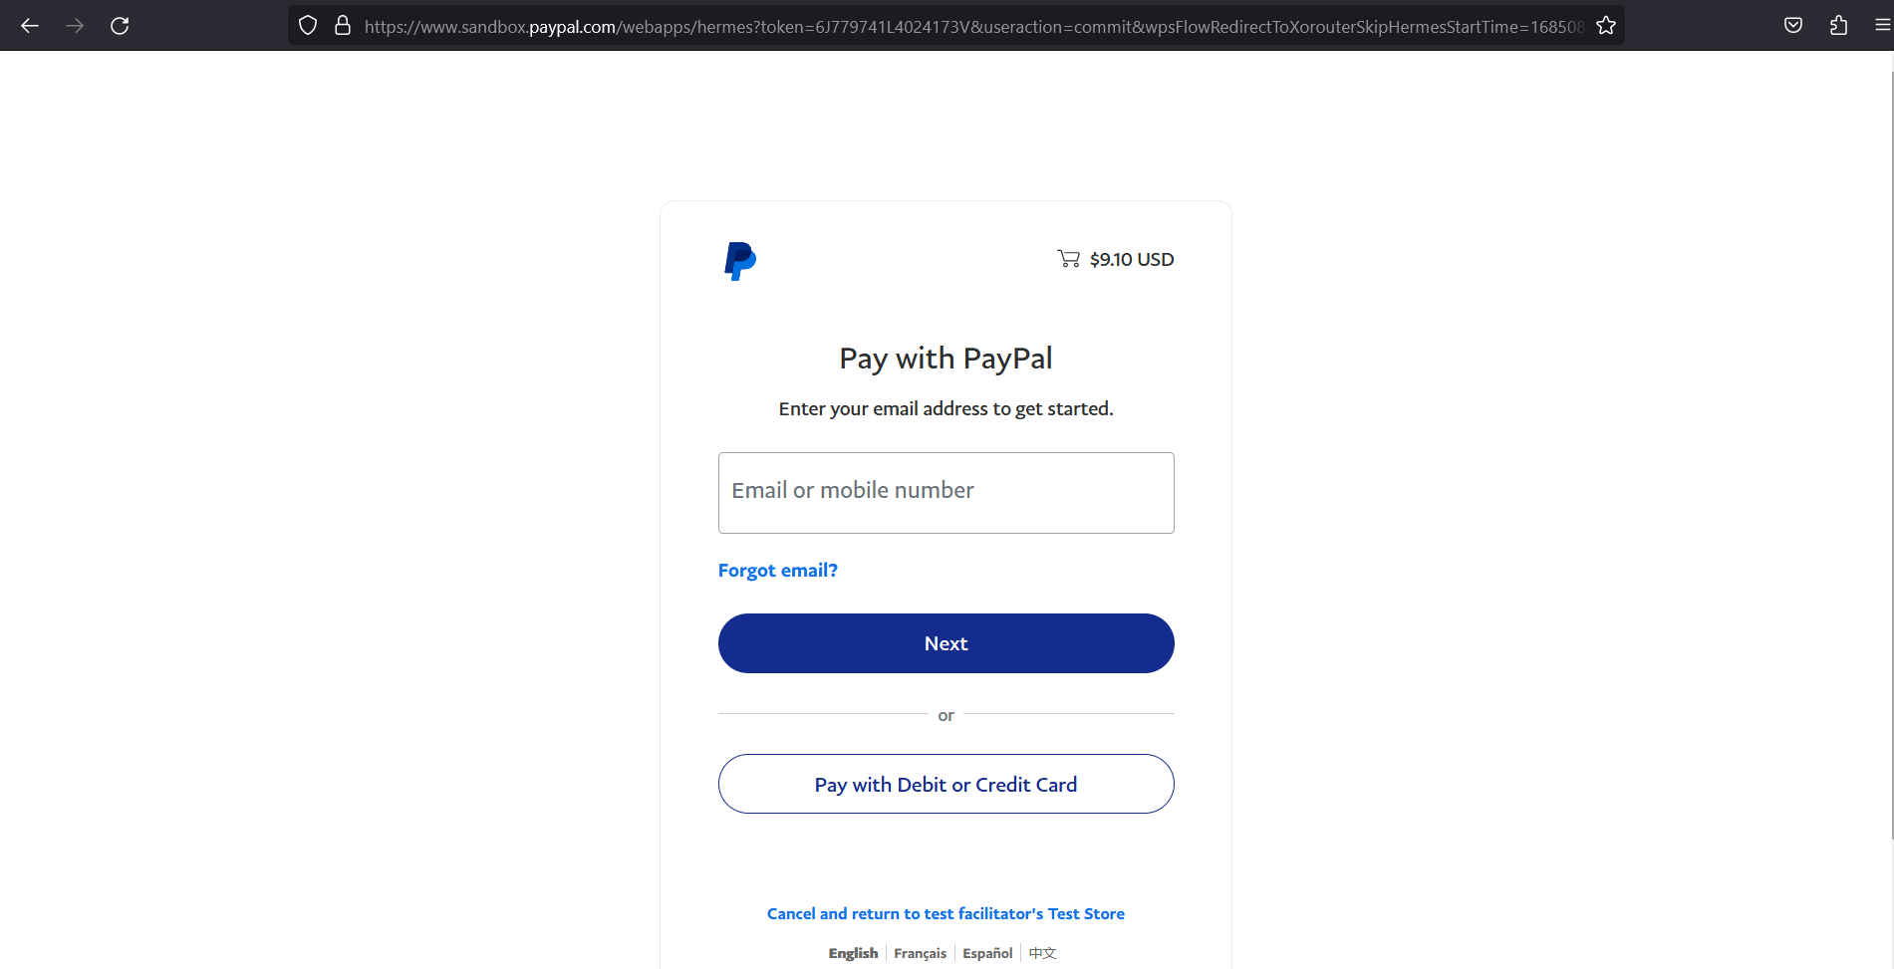

XI. CUSTOMER DASHBOARD

Access to a dashboard will be provided to the customer where they can account details and edit their profile details.

